**GUIDELINES AND PROCEDURES FOR ONLINE LOAN APPLICATION AT HIGHER EDUCATION COUNCIL (HEC) ACCADEMIC YEAR 2024**

**Step 1**. **Opening the link**

Open the link: <https://hecmis.hec.gov.rw/> , click to apply.

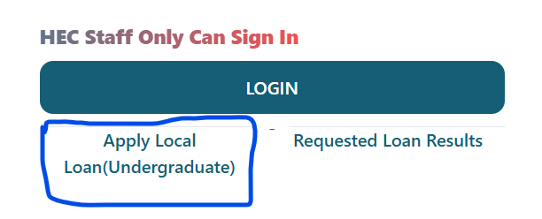

**Step 2**. **Filling up the Application Form, Eligible Candidates are those who completed their Secondary Education 2022/2023 Academic year and are admitted to study in University of Rwanda UR in 2024.**

After opening the link, Click Apply Local Loan button for Undergraduate Applicants,

No need for Sign up for Local Loan Applicants.

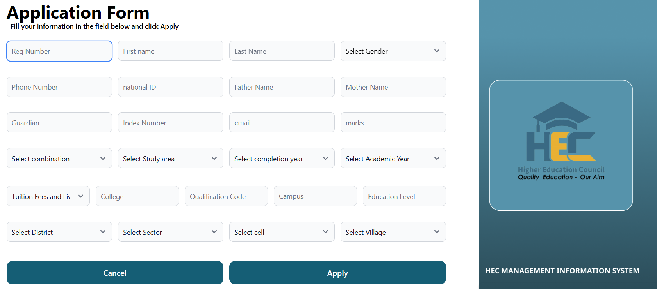

Enter your registration number provided by UR and the form should be appear as indicated below.

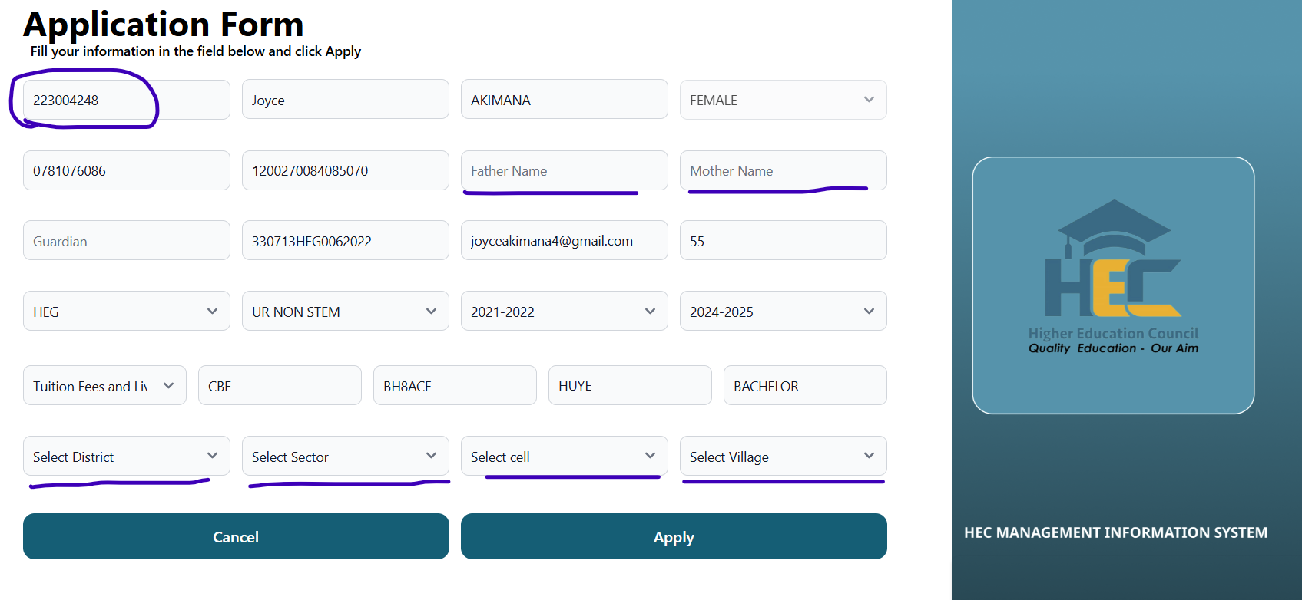

There are Auto generated information from your previous applications, but the underlined area needs you to Put valid information which includes: Father’s Name, Mother’s Name, Drop down Selection for District, Sector, Cell and Village.

**Step 3**. **Completing application process.**

Once form is complete filled, then click on Apply Button You will see a pop-up message indicating that The Local Loan Application is Successful Received.

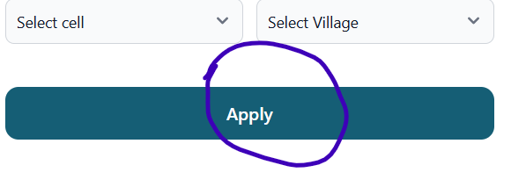  
**Note: After successful application, you can check your result after application Deadline by**

**Clicking on Request Loan Results Button and Enter your Registration Number**

